Week 1 – Running (TK-2nd)

Have student run in place or around your yard for 1 minute. Explain cues from the appropriate diagram below (TK, K, 1st, or 2nd). Have student run in a straight line 4 times, providing feedback after each attempt.

End of Lesson Activity - Have student run and pick up 4 objects, one at a time. Timing their attempt will increase the students enjoyment and likelihood they will want to try again.

TK ---->
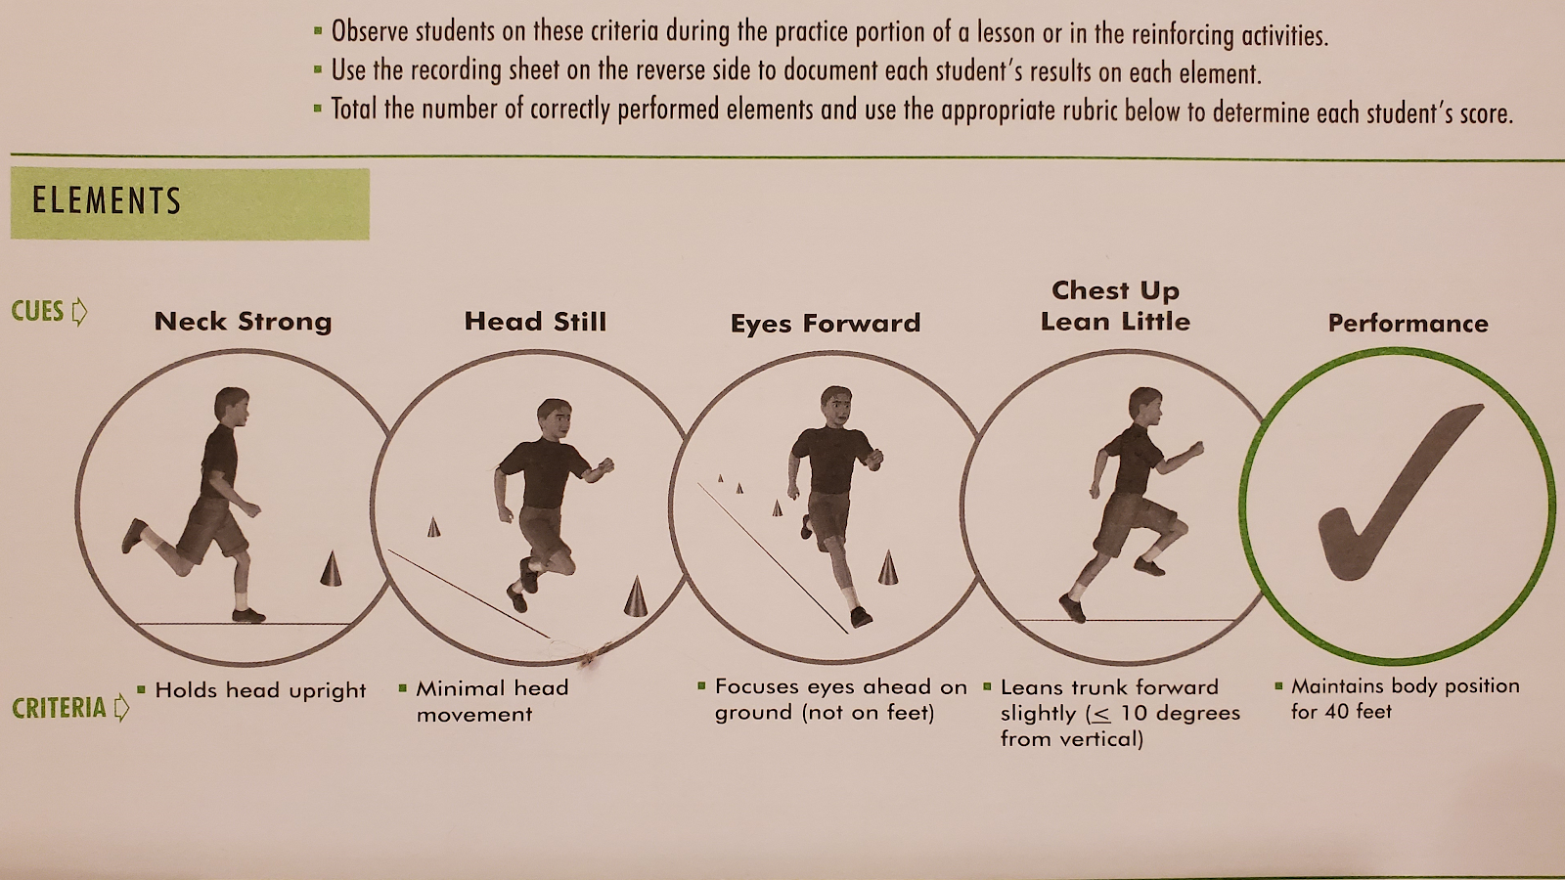

K ----->
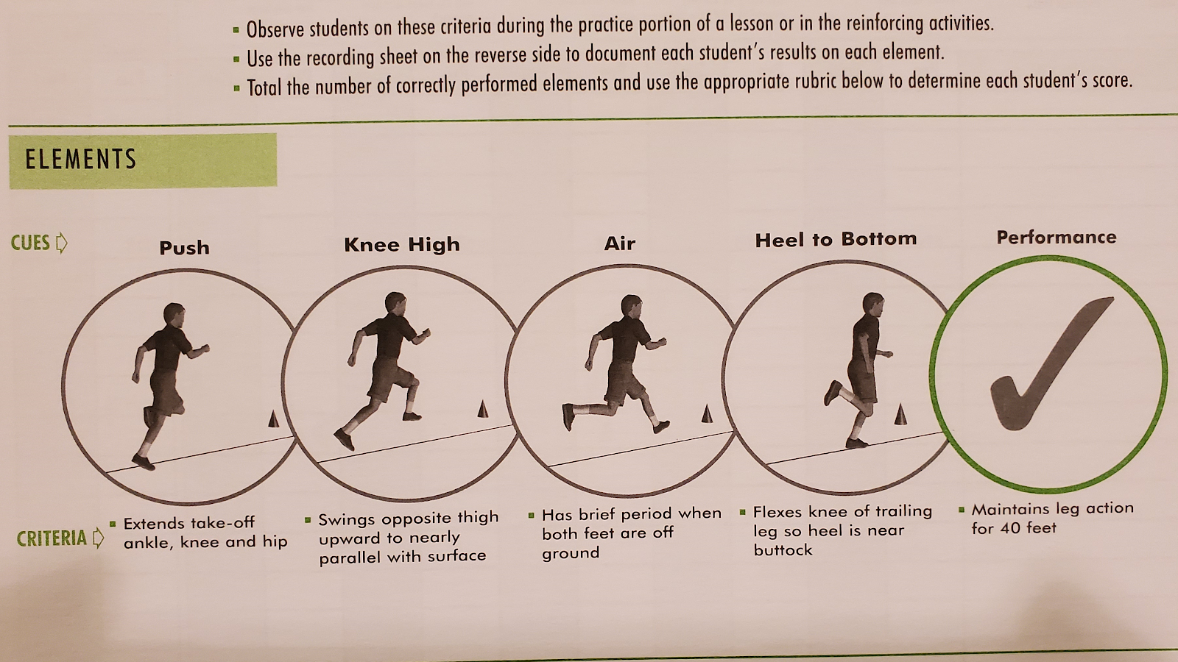

1st --->
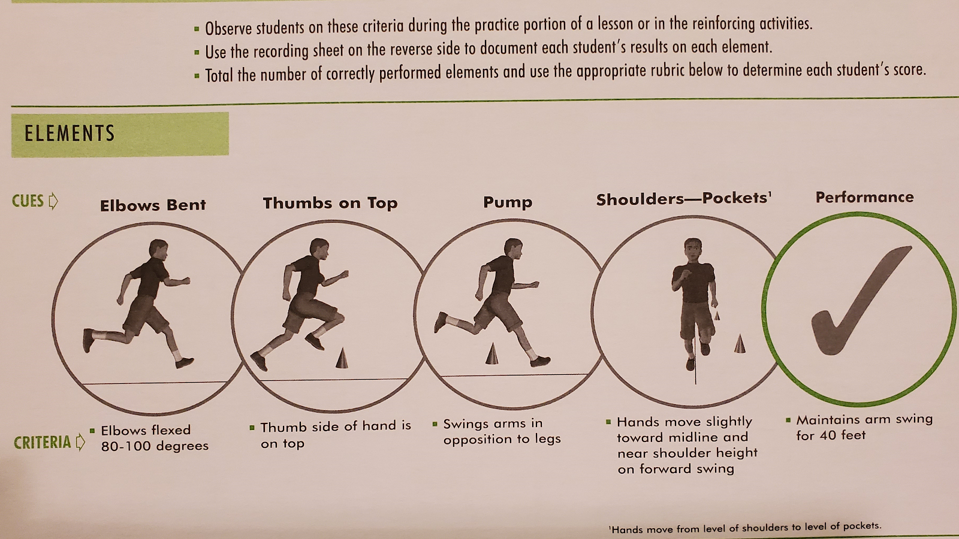

2nd -->
