Week 1 – Underhand Throw (3rd-5th)

Have student warm up by jogging, skipping, sliding, doing karaoke, and sprinting. If the student cant go outside have them run in place for 1 minute. Explain cues from the appropriate diagram below (3rd, 4th, or 5th). Have student perform the skill for 4 turns, consisting of 5 attempts each. Provide feedback after each attempt.

End of Lesson Activity - Student can play horseshoes, corn hole, etc.

3rd --->
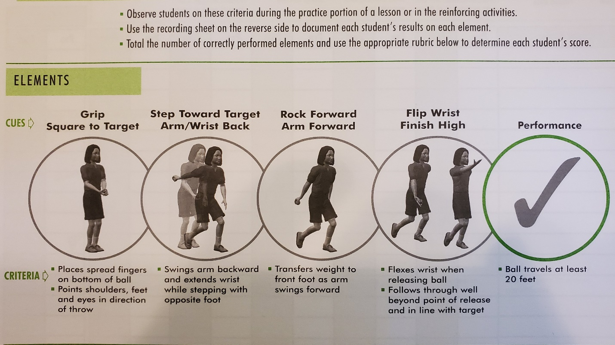

4th --->
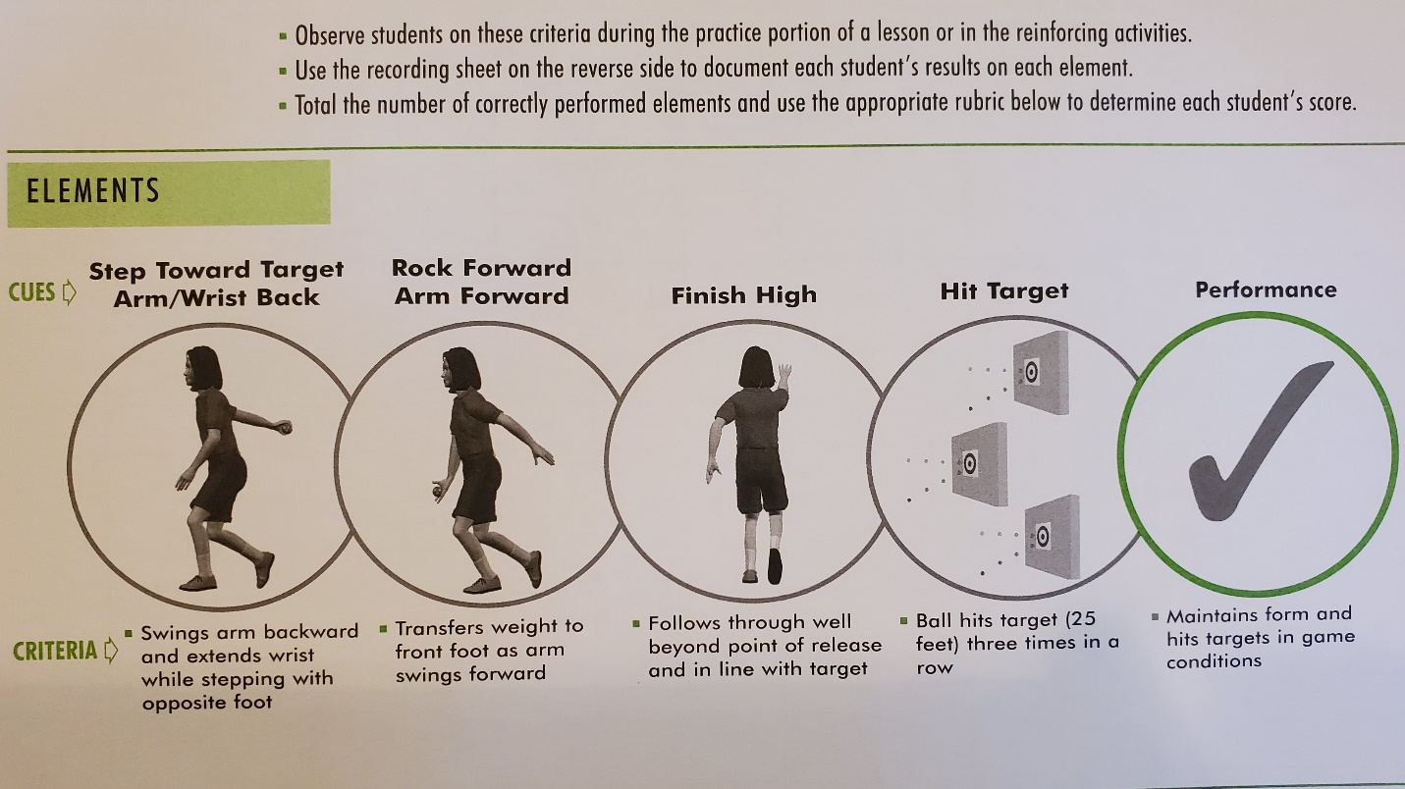

5th --->

