Week 2 – Hopping (TK-2nd)

Have student run in place or around your yard for 1 minute. Explain cues from the appropriate diagram below (TK, K, 1st, or 2nd). Make sure to provide feedback. Once student has mastered their grade level, try the next level if possible. If student is able to complete at least the 1st grade level, have them try the activity.

End of Lesson Activity - Use sidewalk chalk to create a hopscotch pattern of rectangles. Next toss a small object into one of the rectangles and then hop through the spaces to retrieve the object.

TK ---->
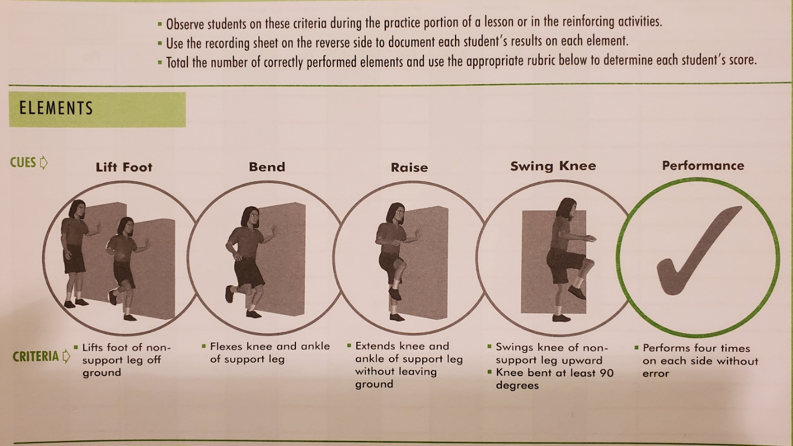

K ----->
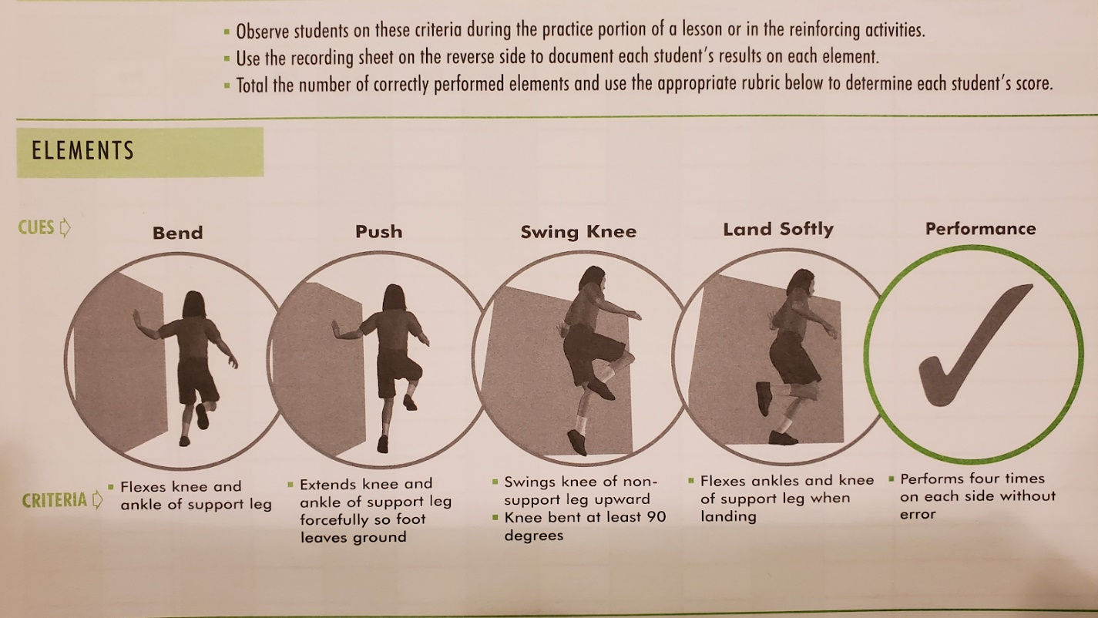

1st --->
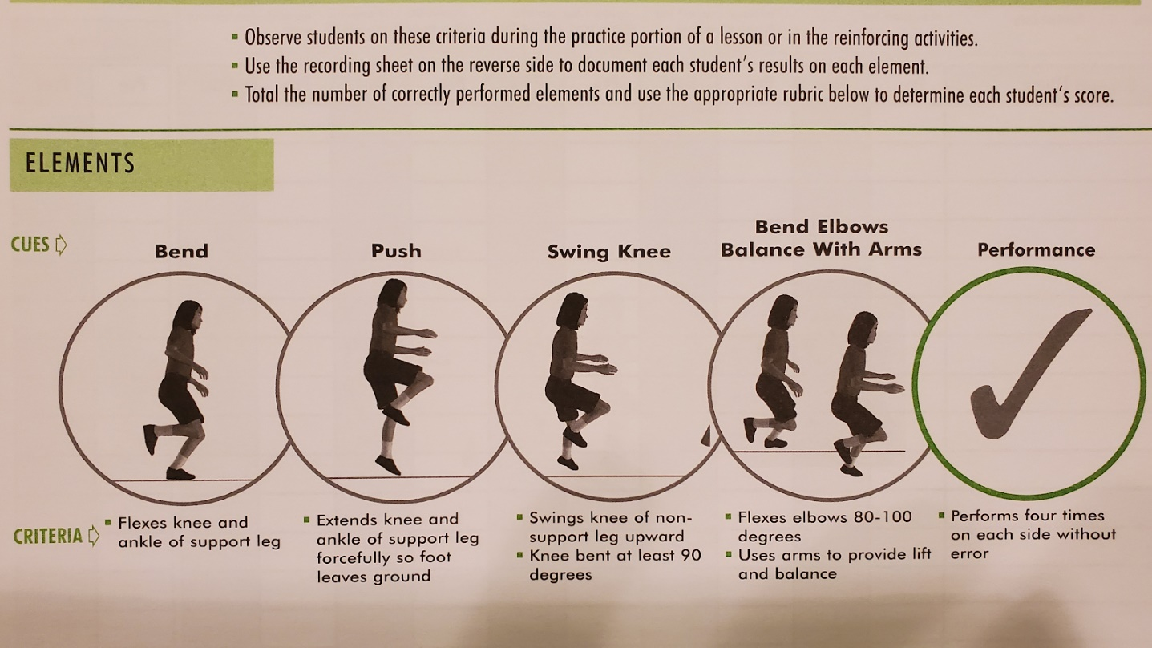

2nd -->
