Week 3 – Sliding (TK-2nd)

Have student run in place or around your yard for 1 minute. Explain cues from the appropriate diagram below (TK, K, 1st, or 2nd). Make sure to provide feedback. Once student has mastered their grade level, try the next level if possible.

End of Lesson Activity - Place 4 objects in a straight line 8-10 feet apart each. Call out the objects, and student slides toward each object called. If the student successfully slides to 10 objects in a row they win. If the student goes toward the wrong object or doesn't maintain proper sliding form, start over.

TK ---->
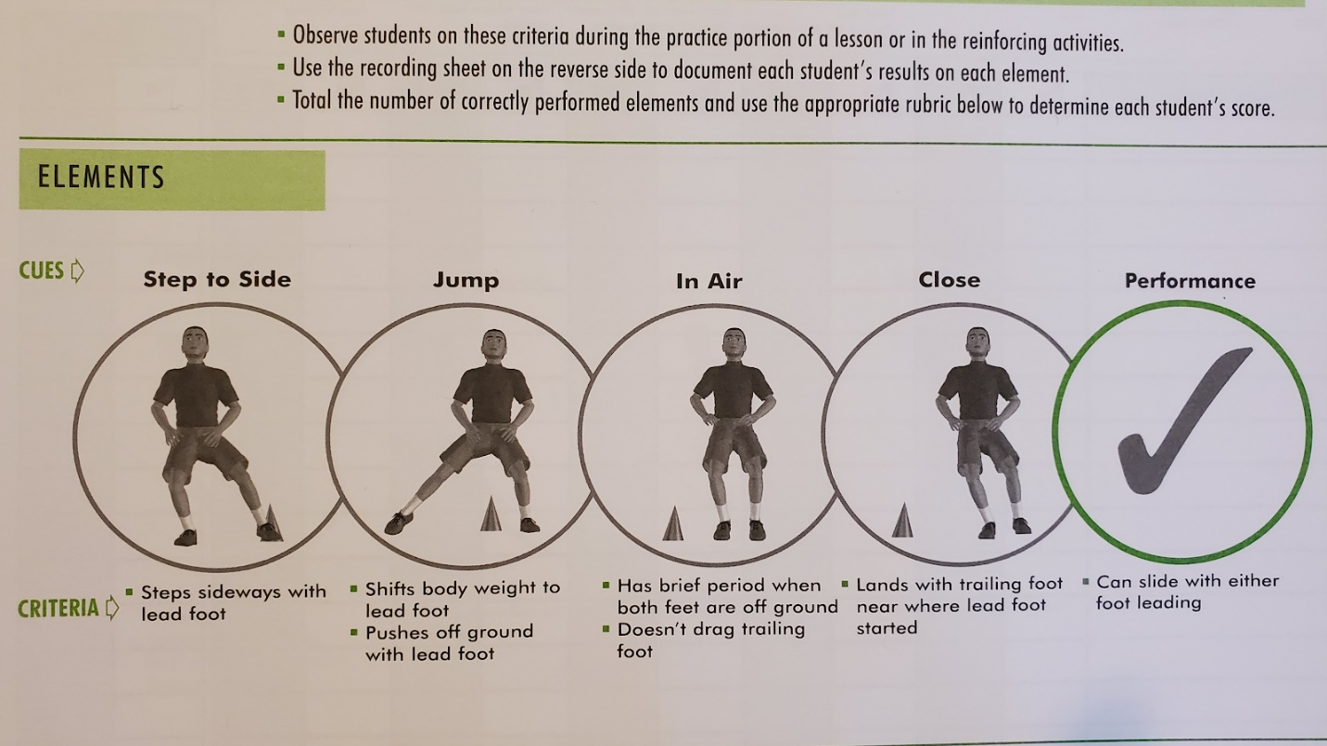

K ----->

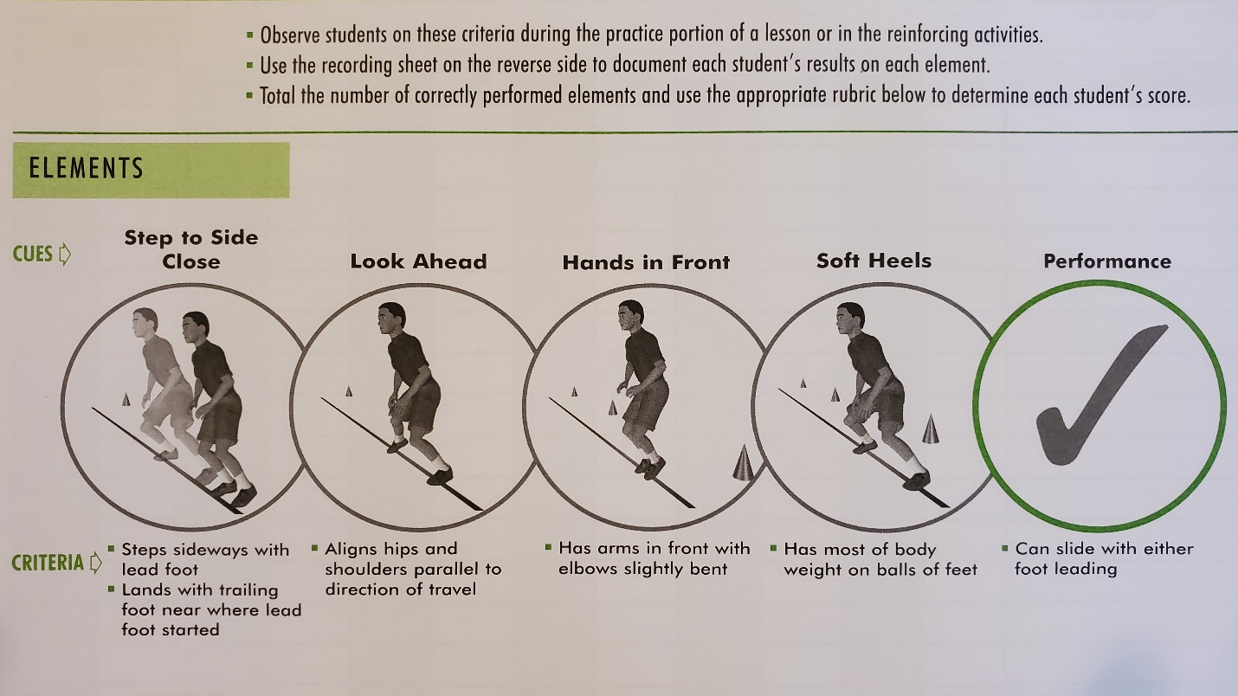

1st --->
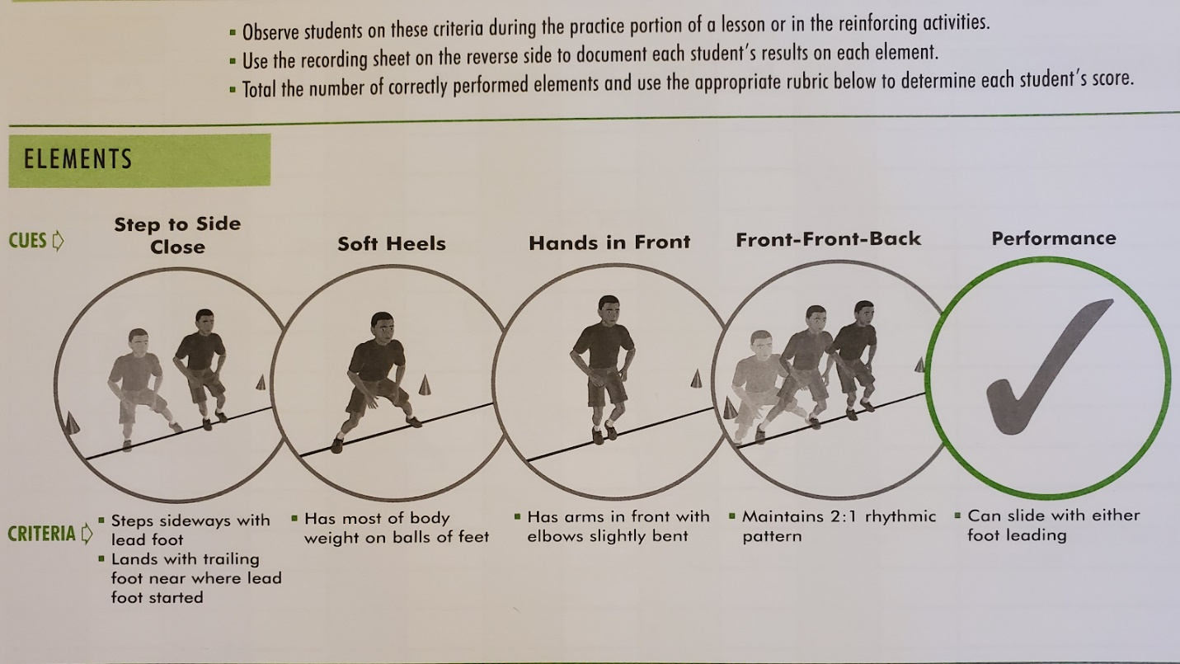

2nd -->
